**Project: Building an ETL Pipeline from Azure SQL to Azure Data Lake using Azure Data**

### Overview

* Objective: Automate data extraction from **Azure SQL DB** into **Azure Data Lake Storage**.
* Tools Used: **Azure SQL, Azure Data Studio, ADF, ADLS, Parquet/CSV**.
* Pipeline Architecture:

**We have the following ERD for a IlluminaireSales database schema.**

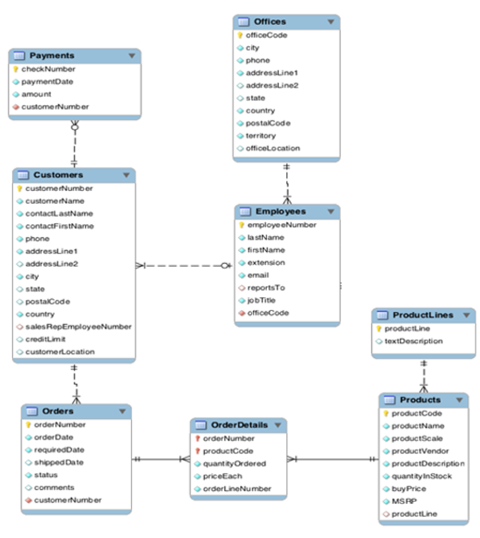

### Phase 1: Create the OLTP Database

1. **Set Up an OLTP Database in Azure SQL Database**

1. **Open Azure Data Studio > New Connection > Use Microsoft Entra ID**

To avoid enabling public access for everyone but to connect from my computer, added the IP to the firewall.

1. **Check if the database is Normalized (3NF)**

A table is in 3NF if:

* It is in 2nd Normal Form (2NF) (no partial dependencies).
* It has no transitive dependencies (non-key columns should depend only on the primary key).

|  |  |
| --- | --- |
| **Table** | **Observations** |
| Offices | No issues |
| Employees | No issues |
| Customers | City, State, Country are redundant (could be normalized into a Geography table) |
| ProductLines | No issues |
| Products | No issues |
| Orders | No issues |
| OrderDetails | No issues |
| Payments | No issues |

Proceeding with the existing schema which is almost 3NF.

1. **Created an Azure SQL Database ‘IlluminaireSales’ using Azure Data Studio**

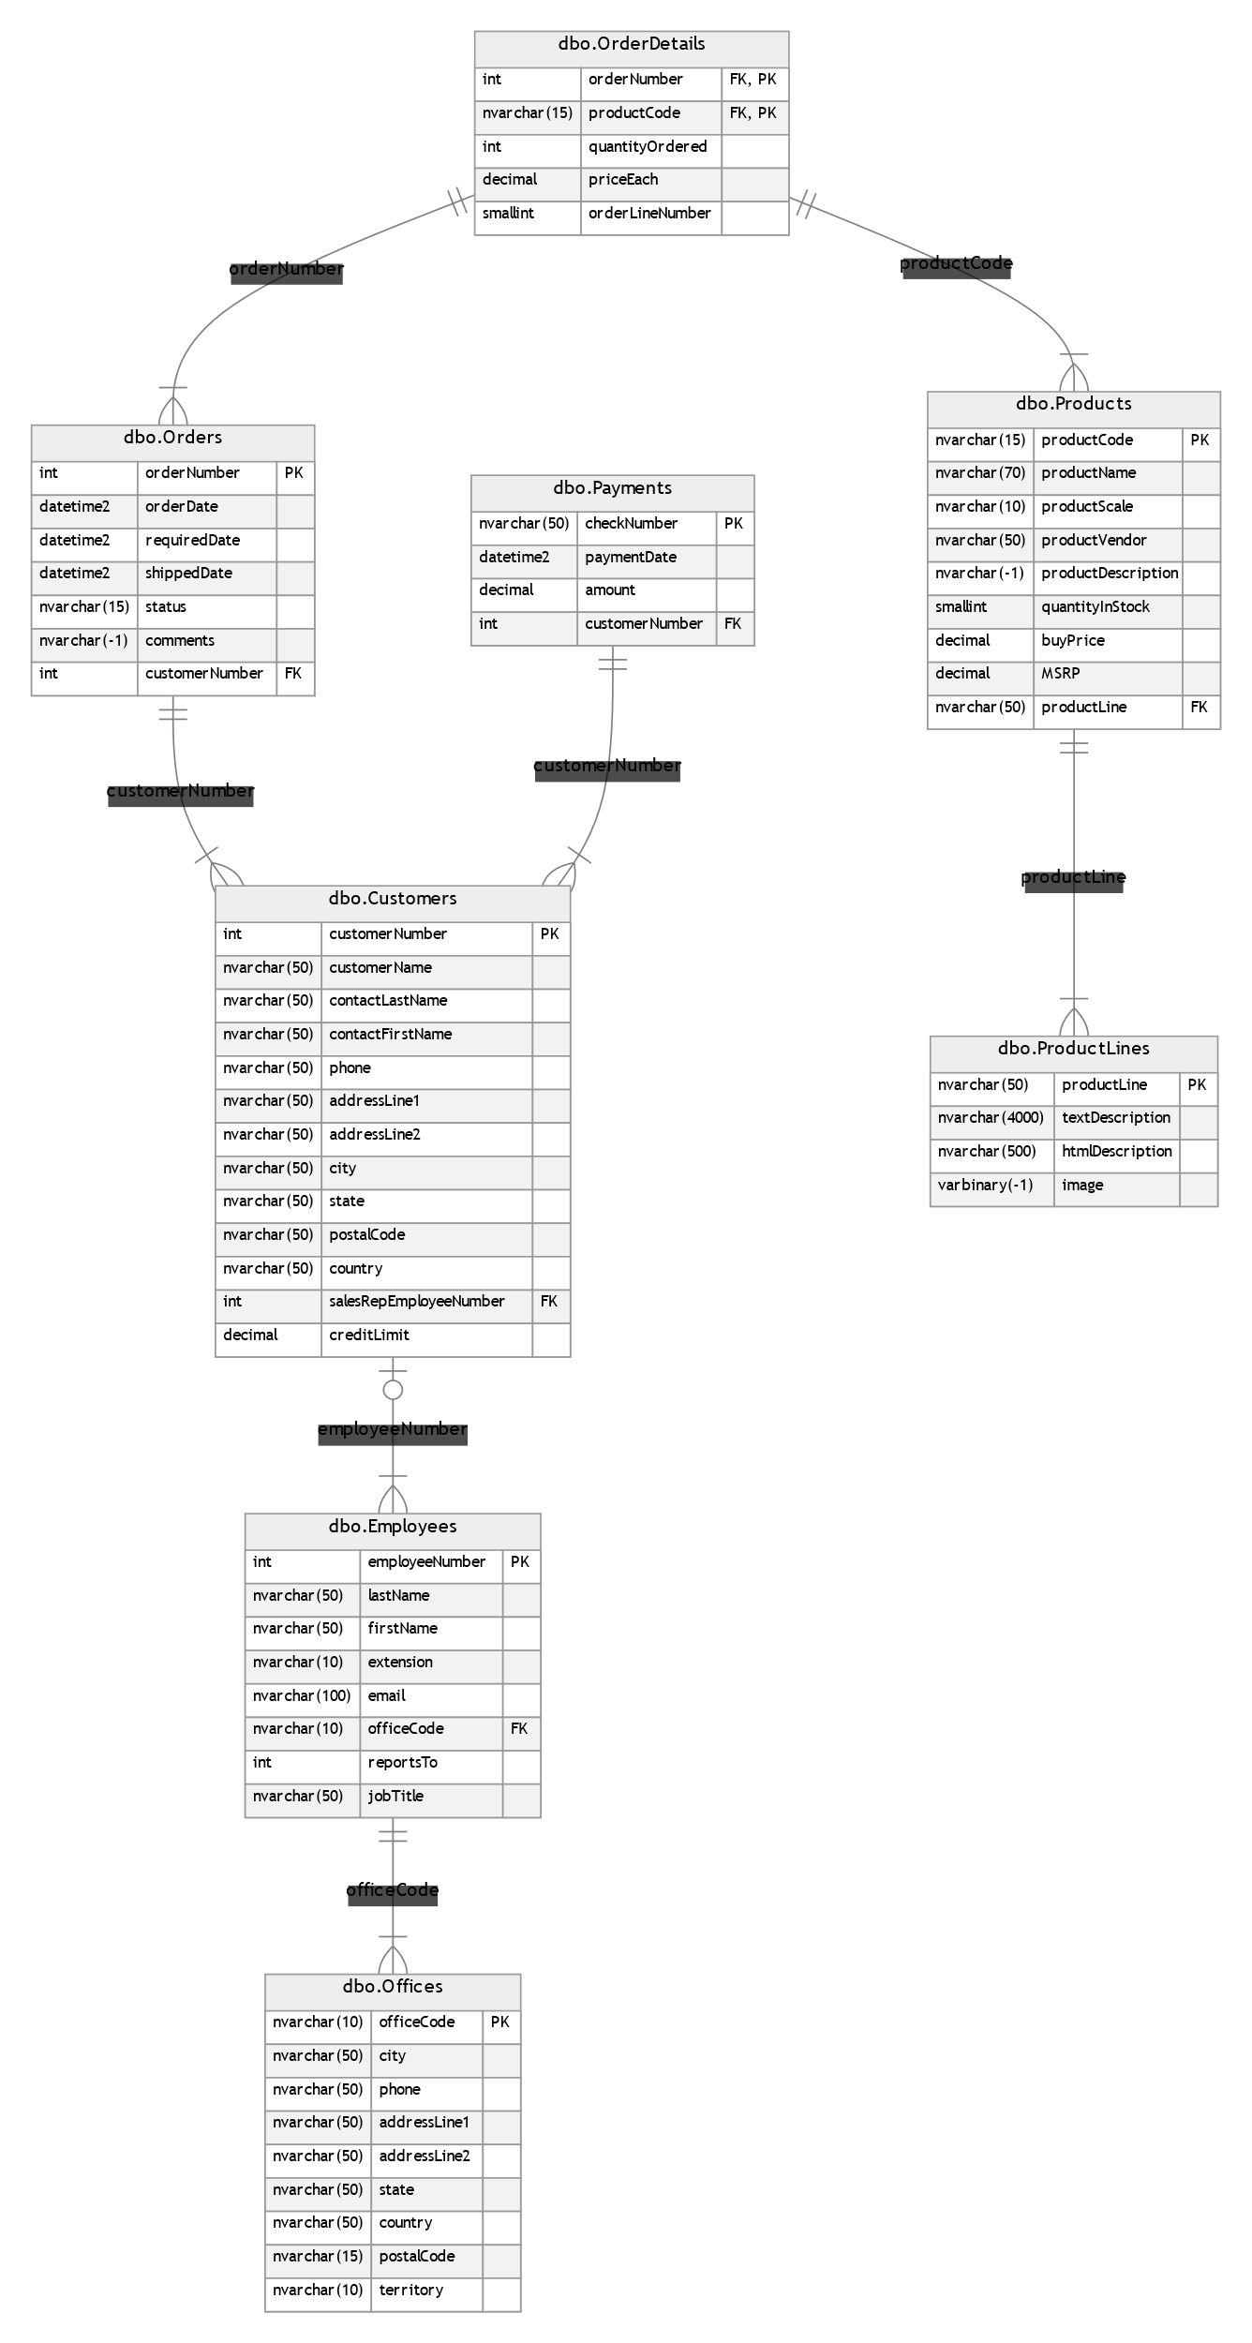

OLTP database setup is complete!

### Phase 2: Implementing the ETL pipeline

1. **Extract Data from OLTP into Azure Data Lake (ADLS) Using Azure Data Factory (ADF)**
   1. Create an Azure Data Lake Storage (ADLS) Account
      1. Storage Account Name: illuminaireadls
      2. Choose the same region as your Azure SQL Database.
      3. Enable Hierarchical Namespace (Required for Data Lake Storage Gen2)
      4. Create a container in ADLS -> Set Public Access Level to Private. A screenshot of a computer

         AI-generated content may be incorrect. A screenshot of a computer

         AI-generated content may be incorrect. A screenshot of a computer

         AI-generated content may be incorrect. A screenshot of a computer

         AI-generated content may be incorrect.
2. **Create an Azure Data Factory (ADF) Pipeline**
   1. Set up ADF
      1. Region: Same as Azure SQL DatabaseA screenshot of a computer

         AI-generated content may be incorrect. A screenshot of a computer

         AI-generated content may be incorrect.
   2. Create a Parameterized ADF Pipeline to Copy All 8 Tables
      1. Create a parameter for TableName - This parameter will allow us to pass any table dynamically into the pipeline. A screenshot of a computer

         AI-generated content may be incorrect.
      2. Add a ForEach Loop to Process All Tables

* + 1. Add the Copy Data Activity Inside the ForEach Loop and add the **source** (Azure SQL Database) where the OLTP data is sitting by creating a linked serviceA screenshot of a computer

       AI-generated content may be incorrect.This parameter will hold the table name dynamically from the ForEach loop.A screenshot of a computer

       AI-generated content may be incorrect. This tells ADF to use the value of the TableName parameter instead of a hardcoded table. A screenshot of a computer

       AI-generated content may be incorrect. This ensures that for each iteration, the table name is dynamically assigned from the list in the ForEach loop. A screenshot of a computer

       AI-generated content may be incorrect.
    2. Now configure the Sink by creating an ADLS linked serviceA screenshot of a computer

       AI-generated content may be incorrect.

* + 1. Now validate the pipeline: **A screenshot of a computer

       AI-generated content may be incorrect.**
    2. Upon Debug, the pipeline runs successfully. A screenshot of a computer

       AI-generated content may be incorrect.
    3. Publish all

### Troubleshooting performed during pipeline creation:

Cannot connect to SQL Database. Please contact SQL server team for further support. Server: 'illuminaire-server.database.windows.net', Database: 'IlluminaireSales', User: ''. Check the linked service configuration is correct, and make sure the SQL Database firewall allows the integration runtime to access.

Cannot open server 'illuminaire-server' requested by the login. Client with IP address '40.119.9.182' is not allowed to access the server. To enable access, use the Azure Management Portal or run sp_set_firewall_rule on the master database to create a firewall rule for this IP address or address range. It may take up to five minutes for this change to take effect.A screenshot of a computer

Issue: Azure Data Factory (ADF) Managed Identity Not Listed in Microsoft Entra ID

Assign Database Permissions

Once your ADF Managed Identity is set as an Azure SQL Admin, grant it permissions at the database level.